August 2025

Port Digitalization Research
Sebastian Leon Ganoza
Sebastian Leon Ganoza | LinkedIn

SFU

Table of Contents
- Executive Summary
Methodology
  - Objective
  - Data Audit and Cleaning
  - Data Segmentation
  - Survey Design
  - Survey Outreach and Follow-up
- Survey Analytics
2.1. Statistical Significance
2.2. Investment Intentions
- Follow-up Analytics
3.1. Statistical Significance
3.2. Growth Trends
3.3. Technology Adoption & Software Use
3.4. Operational Priorities
3.5. Planning Horizons
- Key Insights and Recommendations
4.1. Methodology
4.2. Survey Analytics
4.3. Follow-up Analytics
- Appendix

Executive Summary
This research, conducted by Sebastian Leon Ganoza, explores digitalization trends across North and South American ports, with a dual purpose: to inform Tidalis’ commercial outreach and to serve as a foundation for future academic inquiry. Through a structured segmentation and survey methodology, the study identifies key operational priorities, investment intentions, and technology adoption patterns among 230 strategically selected ports.
Key findings include:
- 70% of ports plan to invest in software within 2 years, yet many still rely on outdated or manual systems.
- Grant funding remains a critical enabler, especially for ports with limited revenue or capital constraints.
- Medium-sized North American ports show statistically significant interest in modernization, particularly in automation and safety.
- Microsoft, ESRI, and Tidalis emerge as trusted platforms, though integration challenges persist.
These insights suggest a clear opportunity for targeted outreach, especially toward operational ports with low system adoption and moderate vessel traffic (<8,000 annually). Tidalis may benefit from tailoring its messaging by executive role and offering benchmarking reports as engagement incentives.

Methodology
The following sections in this document provide context on the guidelines and criteria used for the research project conducted by Sebastian Leon Ganoza on port digitalization.
Objective
The research was meant to be used as an initial point to possibly further my studies through the study of the maritime industry and the impact of digitalization. In addition, it was meant to be used as a tool to inform Tidalis marketing and sales, in efforts to communicate with and reach external audiences.
Data Audit and Cleansing
The catalog of ports came from an internal Tidalis database (sources used for this are WPI – World Port Index
- Full Name: World Port Index
- Published by: National Geospatial-Intelligence Agency (NGA), USA
- Purpose: Provides detailed geographic, operational, and service-related data for thousands of ports worldwide.
- Use Case: Widely used for maritime navigation, planning, and port benchmarking.
- View official source
WPS – World Port Source
- Full Name: World Port Source
- Published by: Independent maritime data aggregator
- Purpose: Offers profiles of ports globally, including maps, cargo statistics, and infrastructure details.
- Use Case: Often used for commercial research, logistics planning, and academic reference.
Note: WPS is not an official government publication like WPI, but it's commonly used in industry and research settings.
DP – DP World Port List
- Full Name: DP World Ports and Terminals
- Published by: DP World, a global logistics and port operator based in Dubai
- Purpose: Lists all marine and inland terminals operated by DP World across 50+ countries.
- Use Case: Strategic reference for trade flows, infrastructure investment, and global supply chain planning.
) ranked using size category on those three lists, mostly updated with ports being categorized by location, country, continent and a unique ID to identify each port as their own unique entity. The catalog also included if the port was already one of Tidalis’ clients.
The project started with data auditing and cleaning as the goal was to standardize and enrich the global port database. After that, the data was enriched by cross-referencing public sources like the PIEP Port Information Platform, UNCTADstat and the World Port Index (NGA). Then, the definition of cargo volume was classified by 5 different port sizes: Very Large, Large, Medium, Small and Very Small. Even though the original catalog included a classification for each port already, an additional size classification was added as it was found that the original classification failed to differentiate between a Very Large port and a port with non-findable information.

Data Segmentation
With Tidalis, it was agreed that the population for the research should be segmented by cargo volume (Size of the port), geographic location (North and South America) and commercial relationship (current client vs. not).
Through this, the database was filtered to select the most suitable ports for the research. A suitable would be classified as financial and operational compared with Tidalis’ current clients. In addition, ports with growth potential would be considered for the research too as Tidalis’ had an idea to introduce a more generalized product.
Including ports with not as much technology, but sufficient resources, was an important part of this research as it would show a correlation between available resources and digitalization. This would be offered through the more generalized product Tidalis. After taking all these into consideration, not all “strategically relevant ports”could be included in the research as some of them did not have any available public contacts to use as a point of communication. At the end of the segmentation, 609 contacts were collected among 230 ports that ranged mostly between CEOs, COOs, CITs, CFOs, and Harbormasters as shown in Figure 1.

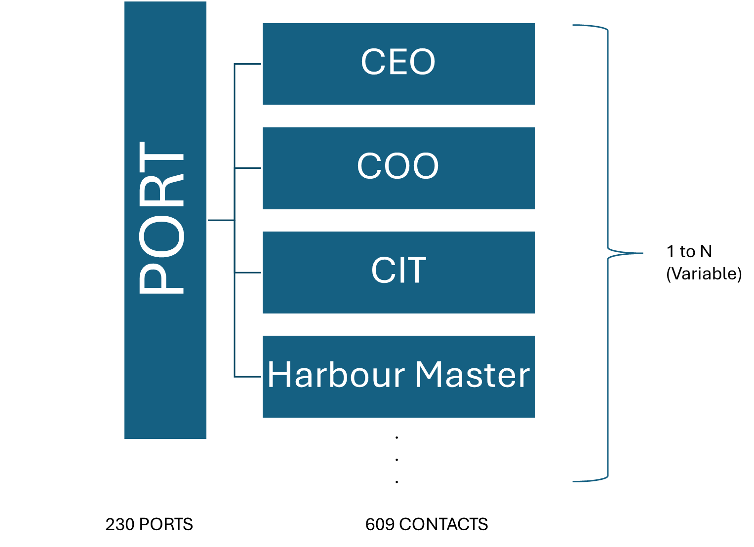
Figure 1. Relationship among contacts and Ports (1 to N)
About 3 contacts per port, going from 1 to 5
Survey Design
After right-sizing the population survey, the key topics were decided to maximize data collection for the research. These included types of operations, digital systems used and ports’ interest in digitalization.
With the topics decided, 9 short closed-ended questions were formulated and tailored to give a wide enough range for all ports included in the survey to respond and allow room for follow-up questions. These 9 questions are shown below:
- How many vessels does your port host yearly?
- How much revenue does your port generate yearly?
- What is the focus of your port business?
- When was the last time you installed or did a major upgrade to software solutions?
- When does your port plan to invest in new software solutions?
- Have you considered investing in any of these software solutions?
- This survey is intentionally short; can I contact you for an online meeting or follow-up email with additional questions?
- Can the information provided be used for further academic purposes?
- Would you like a copy of my report for your benchmarking purposes?
For the creation of the survey, LimeSurvey appeared to be the best for the research. LimeSurvey has an outstanding reputation and recommendations from professionals, it allows the creation of complex surveys with customized logic, offers data analysis and export and it’s easy to install or access in any device.
Survey Outreach and Follow-Up
With the contacts segmented and the survey designed, the next step was to create a way in which the response rate could be maximized, and responders could be motivated to answer in the most honest way possible.
Email campaigns were tailored with distinct messaging for the different segmentations (operations, finances, if they are a client for Tidalis’, and the possibility for them to be interested in investing in digitalization). In addition, 5 reminders would be sent to answer the survey, avoid overwhelming people and still targeting a high response rate. Finally, survey results would be used as an incentive in exchange for completing the survey.

Survey Analytics
Over the span of 5 weeks, the survey got responses from 42 different ports. The funnel used to measure survey performance by ports for my research is as indicated by Figure 2
Including each step of the segmentation, the broad initial universe of ports was 7 573 globally, without excluding ports regardless of region or cargo activity. After applying a regional filter and counting only ports in North and South America, only 2 434 ports remained, which represented 32.14% of the initial global port universe. This significant reduction was necessary to emphasize the regional focus of the research. By further filtering by operational and financial port activity, only 502 were classified as suitable for the research, which represents 20.62% of the regional filtering. With this reduction, a final filter was applied to only count ports that had publicly available contacts with an email to reach out, which ended up reducing the population to 230 ports or 45.82% of ports from what had already been filtered. In the end, out of these 230 ports, only 42 ended up sending a response, which encompassed 18.26% of the ports that were contacted.
A key strategy used for the research was to send my survey to multiple contacts per port trying to at least aim for a response per port. Only 5 ports sent multiple answers.
Typical response rates for cold B2B email surveys hover between 5% and 15%, especially when targeting senior-level contact or organizations like ports (Belkins, 2025), which meant that the message stood out, whether by the subject line, clarity, relevance or perceived value.
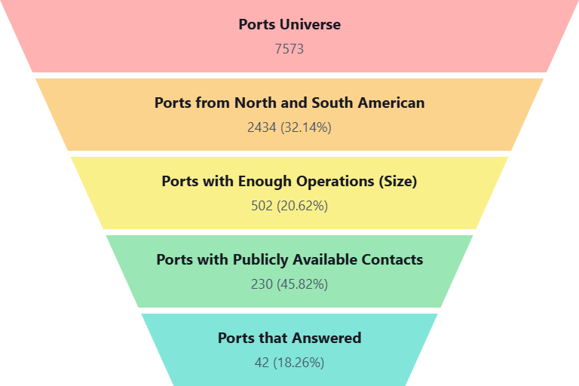
Figure 2. Funnel of survey performance by ports
Statistical Significance
With 42 different ports responses out of 230 ports that were included in the research proves that the study has enough statistical significance to be taken as reference for future research. Figure 3 shows the calculation that reach to this conclusion
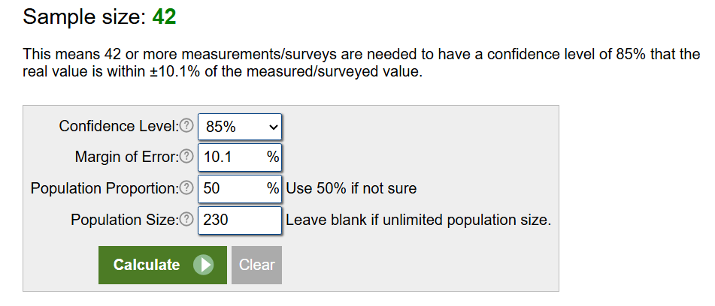
Figure 3. Calculation that proves statistical significance of my study
Most of the responses from the survey came from ports classified as small, medium and large, with the majority being North American medium sized ports, handling $250M USD annually and with vessel volumes of 300-2000. 21 out of 42 (50%) of the responses were from medium sized ports. The population of medium sized ports included in the survey was 65. This makes medium sized ports responses statistically significant as shown in Figure 4.
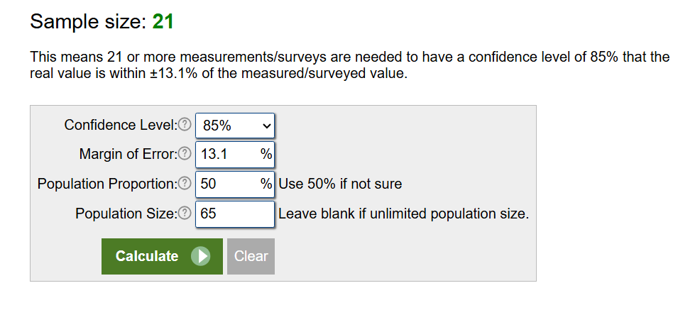
Figure 4. Calculation that shows statistical significance of medium sized ports responses
In terms of regional responses, 40 out of 42 responses came from North American ports while the remaining 2 were from South American ports. The population for North and South American ports were 179 and 51 respectively. This makes North American responses statistically significant in comparison to South American responses. This is proven by Figures 5 and Figure 6.
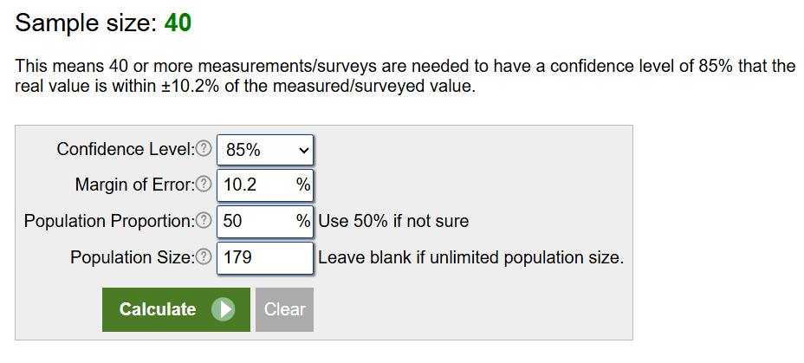
Figure 5. Calculation of statistical significance of North American ports responses
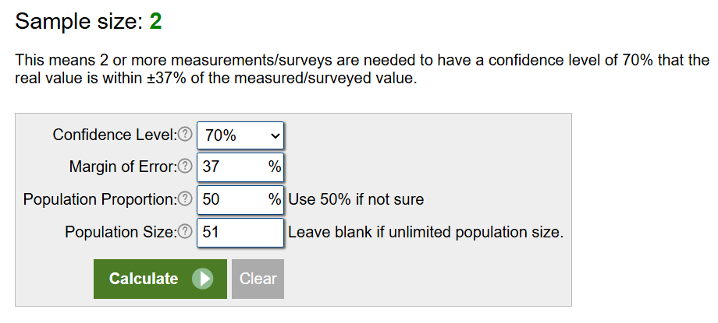
Figure 6. Calculation of statistical significance of South American ports responses.

Investment Intentions
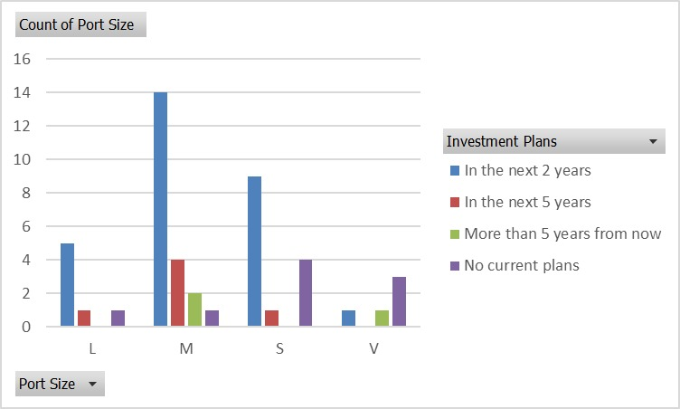
Figure 8. Graph of correlation between port size and investment plans
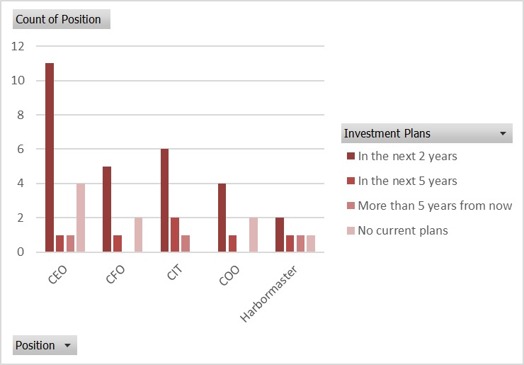
Figure 9. Correlation graph between investment plans and responders’ position
Figure 8 and Figure 9 indicate that nearly 70% of the ports plan to invest in technology within the next 2 years, which noted that despite future investment intent, several ports still have current software gaps, especially in security and digital twin.
Low response digital tools like Maritime Single Window and Maritime Situational Awareness Viewer were an indicator that even though Maritime Single Window has become a mandatory tool for ports to have, ports have adapted current software to fulfill that role instead of investing in new software
Responses also showed that ports that have invested in software solutions between the last 2 and 5 years are more likely to have additional investment plans in the next 2 years as shown by Figure 10
Finally, responses indicated that more operational ports are more likely to invest sooner in comparison to less operational port as shown by Figure 11.
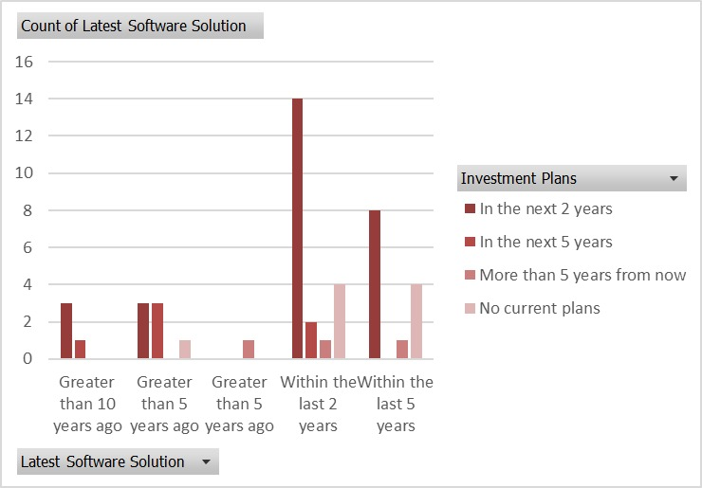
Figure 10. Correlation graph between investment plan and latest software update
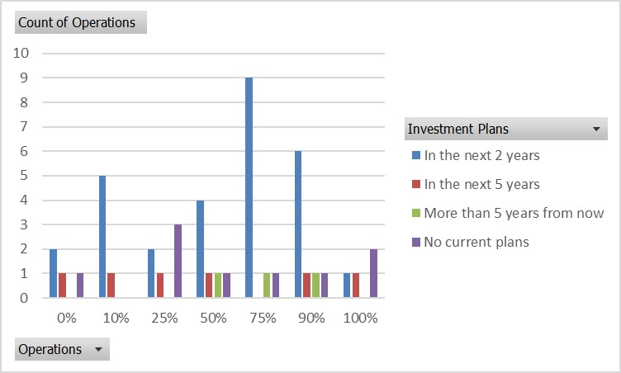
Figure 11. Graph of correlation between operations at ports and investment plans

Follow-Up Analytics
Responses included only North American ports with sizes as small/medium/large that agreed to have a further conversation. South American ports were not statistically significant enough to pursue further.
32 out of 42 (76.2%) initial ports that responded the first survey agree to participate further. Removing South American ports (2), it makes it 30 out of 40 (52.5%), from which only 17 ended up answering (56.7%). However, 7 out of those 17 ports I had online meetings with instead of sending additional questions through email. 6 out of the 17 ports that ended up answering came from the influence of their relationship with Tidalis’ (clients). This is all as shown by Figure 12.
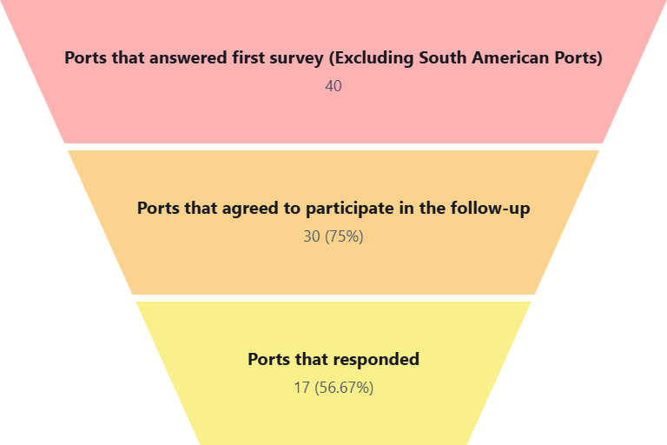
Figure 12. Funnel of follow-up performance by ports

Statistical Significance
With 17 responding out of 40 ports that agreed to be a part of the follow-up, it is shown that this second part of the study was not as significant as the first part. However, there is still some value to be taken from it. All this proven as shown by Figure 13.
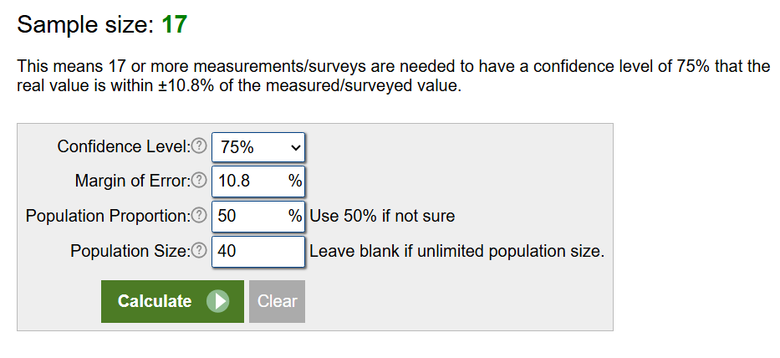
Figure 13. Calculation of statistical significance of follow-up
Growth Trends
Every port that was part of the follow-up showed growth in either cargo or vessels and even if they have just remained stable, no part has shown a worsening in operations. Larger ports showed a decreased in vessels visits but an increase in cargo, indicating a financial betterment that enabled improvement in infrastructure and/or operations in addition to the potential of having fewer but larger vessels that carry more cargo.
In terms of digital tools usage, Maritime Single Window deployment is uneven, possibly reflecting adaptation from other existing software to take the role of it. There is an increasingly embrace of visual planning tools, which indicates a move toward digital dashboarding and enhanced situational awareness. Operational ports with higher traffic have started prioritizing berth coordination while ports that lack tools may suggest the continuation of usage of manual processes due to comfortability.
Security digitalization seems to be a bigger issue for ports that count with higher digitalization while opposed ports seem to not be interested in taking the jump due to aversion or underfunding. (European Transport Research Review, 2021)
Regarding grant funding, ports keep considering it as the main source of cash for digital investments as its a reliable source compared to revenue (American Association of Port Authorities, 2020)
Technology Adoption and Software Use
Most ports seem to prioritize integration while they struggle to balance their many different digital tools. Ports with larger operations seem to opt for building their own personal software solution rather than investing. Microsoft was the most frequently mentioned brand, indicating its widespread trust and integration across ports. Other recurring platforms include Tidalis, Pacsoft, ESRI, and SharePoint, indicating the usage of a mix of general-purpose and industry-specific tools. Ports with outdated software or manual processes reported interest in improved automation and communication, signaling readiness for digital transformation.
Operational Priorities
When purchasing or integrating a software or digital tool into their ports, most ports prioritize safety, efficiency, automation, and customer service as the most important factors when taking that decision. These priorities align with global trends in smart port development and digital logistics. (Hapag Lloyd, 2025)
Planning Horizons
Investment plans fluctuate between 1-5 years in advance, showing a medium-term strategic mindset and risk neutrality. This is likely related to the fact that majority of ports at this point in the study did not plan to use external funding. A few ports investment plans were between 6-12 months ahead. This is possibly due to budget constraints or riskier management styles.
Regarding investment plans, most ports reported using 1-5% of their revenue in IT investment. A couple of outliers reported using >15% which once again reflects an aggressive interest in digitalization.
When deciding which products to invest in, ports are still split between off-the-shelf products and custom one-off solutions. On the one hand, smaller ports lean toward custom solutions, possibly due to unique operational needs. On the other hand, larger ports often prefer scalable off-the-shelf products, likely due to difficulty in integration and already existing operational tools in their ports.
Nonetheless, ports with recent tech upgrades have shown higher growth than other ports. Hence, why ports are looking to invest. However, this has also created the dilemma: Are ports growing due to technology? Or is growth forcing ports to invest in technology? Taking into consideration region and lack of external as well could be the reason why some ports haven’t pursued digitalization yet.

Key Insights and Recommendations
Methodology
- The progressive filtering suggests a well-structured survey targeting strategy, focusing first on geography, and then on operational and financial relevance.
- Survey reach indicates statistical significance as it has an 85% confidence level on a 10.1 margin of error. This reflects that even though the population is effective, the goal of the research was to focus on precision targeting, limiting the generalizability of results.
- Response engagement is moderate; depending on the criticality of data collection, strategies such as reminders, personalization, or follow-ups could increase this rate.
Survey Analytics
- Only ~20% of respondents identify as current clients, which makes it promising for cross-sell or upsell
- Most ports are open to further contact via email or online meetings, signaling positive engagement potential and the need and interest for ports to learn about new technologies that could solve problems for them
- Strong lead pool: Based on the responses, 30% were open to receiving a follow-up, from which most are not clients
- Low adoption = high potential: Many ports lack full digital tools like ERP, digital twin or Maritime Single Window
- Segmented targeting: Tidalis’ target should focus on medium/large ports with low system adoption, especially those with <8 000 vessel traffic.
- Use survey report as a hook: Offering the results to participants could support engagement
- Tailor by role: C-level executives and IT leaders require different messaging so Tidalis’ should implement communication based on strategy vs. system integration
Follow-up Analytics
- Modernization (Current Technology, Improved Automation) is strongly associated with Efficiency, Safety, and Customer Service.
- Outdated Software correlates with a desire for change but often lacks the growth momentum seen in more modernized ports.
- Growth tends to occur in environments where efficiency and safety are prioritized and supported by current technology. Ports using similar platforms (e.g., Microsoft, ESRI) could benefit from shared best practices and regional partnerships.
- Over 60% of ports indicate having an interest in a software solution like Terminal Operations, PMIS, or ERP in the next 2 years. In comparison, 25-30% of ports show no current plans and/or intention to invest in any software solutions in the next 2 years
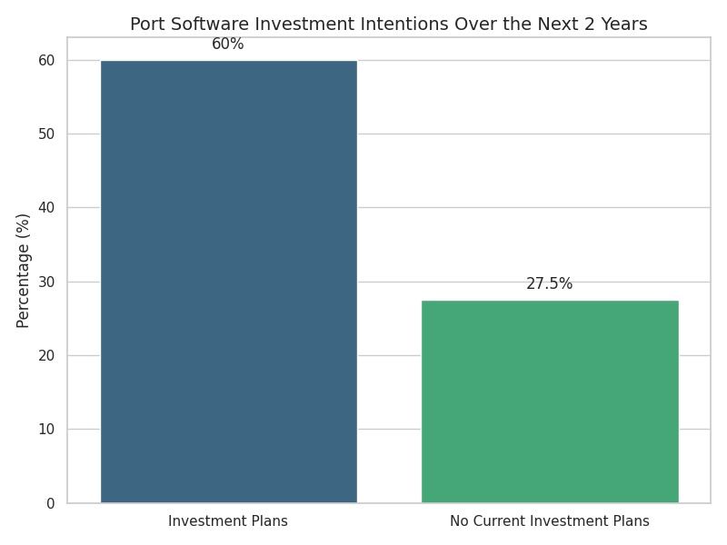
Appendix
Survey Raw Data (By responder)
How many vessels does your port host yearly?
- <300: 11
- 301-2000: 27
- 2001-4000: 3
- 4001-8000: 2
- >8000: 2
- Prefer not to share: 2
How much revenue does your port generate yearly?
- <$5M USD: 11
- <$50M USD: 19
- <$250M USD: 8
- <$500M USD: 1
- <$1B USD: 4
- >$1B USD: -
- Prefer not to say: 4
What is the focus of your port business?
- Landlord
  - 0%: 4
  - 10%: 10
  - 25%: 11
  - 50%: 5
  - 75%: 6
  - 90%: 6
  - 100%: 5
- Operations
  - 0%: 4
  - 10%: 6
  - 25%: 6
  - 50%: 7
  - 75%: 11
  - 90%: 9
  - 100%: 4
When was the last time you installed or did a major upgrade to software solutions?
- Within the last 2 years: 22
- Within the last 5 years: 13
- Greater than 5 years ago: 8
- Greater than 10 years ago: 4
When does your port plan to invest in new software solutions?
- In the next 2 years: 29
- In the next 5 years: 6
- More than 5 years from now: 3
- More than 10 years from now: 0
- No current plans: 9
Are you considering investing in any of these software solutions?
Port Management Information Solution | 43%
Asset Management Solution | 38%
GIS Platform | 36%
Finance/Accounting Solution | 36%
Terminal Operating Solution | 29%
Vessel Traffic Services Solution | 26%
Security Management Solution | 26%
Digital Twin | 26%
ERP | 24%
Maritime Single Window | 17%
Maritime Situational Awareness Viewer | 9.5%

This survey is intentionally short; can I contact you for an online meeting or follow-up email with additional questions?
- I can participate in an online meeting: 5
- I can answer follow-up questions through email: 26
- I can participate in an online meeting and/or answer follow-up questions through email: 5
- I would not like to participate further: 11
Can the information provided be used for further academic purposes?
- Yes, including port name: 16
- Yes, but anonymously: 26
- No: 5
Would you like a copy of my report for your benchmarking purposes?
- Yes: 38
- No: 9

Follow-up Raw Data
Has there been a trend in vessel visits over the last 5 years?
- Increased Visits: 6
- Decreased Visits: 1
- Remained About the Same: 4
Has there been a trend in cargo volume over the last 5 years?
- Increased Amount of Cargo: 8
- Decreased Amount of Cargo: 0
- Remained About the Same: 3
How much of your yearly revenue is allocated to IT investments?
- <1%: 2
- 1%-5%: 5
- 5%-10%: 3
- 10%-15%: 0
- >15%: 1
How long in advance do you have to plan to invest in IT procurements?
- Immediately: 0
- 1-6 months in advance: 0
- 6-12 months in advance: 4
- 1-5 years in advance: 7
- > 5 years in advance: 0
Do you typically need external funding to invest in IT procurements?
- Yes: 3
- No: 8
Have you considered any specific software or brands for your desired software solutions?
- First Option:
  - Microsoft: 5
  - Workday: 1
  - Tidalis/Saab: 1
  - PortControl: 1
  - N/A: 3
- Second Option:
  - ESRI: 1
  - SaaS Hosted: 1
  - Tidalis: 1
  - Salesforce: 1
  - Verkada: 1
  - Pacsoft: 1
  - Microsoft: 1
  - N/A: 4
- Third Option:
  - Sharepoint: 1
  - Industry Specific:1
  - Advent eModal: 1
  - SVK Systems: 1
  - Elite Dynamics: 1
  - Symantec: 1
  - N/A: 5
What are the most important factors to make you invest in new software solutions?
Outdated Software Replacement | 10
New Functionality Needed due to Change in Operations | 6
New Functionality Needed due to Growth | 5
Safety | 1
Efficiency | 6
Improved Automation | 8
Improved Communication between Departments | 3
Improved Customer Service | 5
Access to the Latest Technology | 0

What are the most important factors in a company offering software solutions?
Reputation | 11
References | 3
Client Quantity | 2
Off-the-shelf Product | 3
Custom-one-off Solutions | 3
Configurability of Products | 8
Certifications (e.g. ISO27001) | 1
Price is the Lowest Available | 2
Size of Company | 0
Location of Company | 1
Company’s Involvement in the Industry | 8

